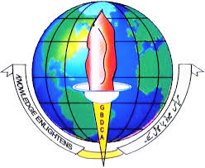 | SHMM GDC ANANTNAG  DEPARTMENT OF ENVIRONMENTAL SCIENCE AND  DEPTT. OF WATER MANAGEMENT | 

- 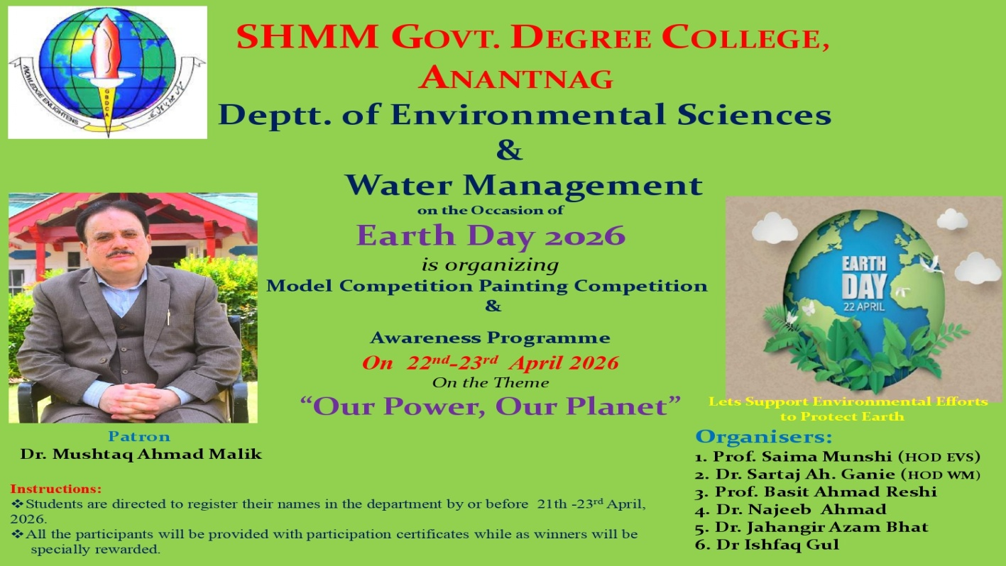
REPORT
Earth Day celebration on 22 and 23 April, 2026 under the theme “Our Power, Our Planet”
The Department of Environmental Science and Water Management Government Degree College Anantnag organized a comprehensive programme under the theme “Our Power, Our Planet” on Earth Day 2026. The initiative sought to integrate scientific innovation, artistic creativity, and environmental awareness to instill ecological responsibility among students.
An Awareness Programme was organized on 22 April, 2026. It comprised lectures, interactive sessions, and discussions between faculty and students. Topics included climate change mitigation, sustainable water management, and community based conservation strategies. Students pledged to adopt eco-friendly practices.
The Model Competition was organized on 23 April, 2026 in which students showcased innovative models pertaining to renewable energy, waste management, and water conservation. Several models demonstrated practical feasibility, highlighting the potential of student research in advancing sustainable development.
The Painting Competition was also organized on 23 April, 2026 .It provided a platform for students to express environmental concerns through art. Paintings vividly depicted themes such as biodiversity preservation, climate resilience, and the centrality of water as a life sustaining resource, reinforcing the day’s theme.
The Earth Day 2026 celebrations at the Department of Environmental Science and Water Management, GDC Boys Anantnag, successfully combined academic rigor, creative expression, and civic responsibility. By aligning scientific innovation, artistic imagination, and awareness initiatives with the theme “Our Power, Our Planet,” the programme contributed meaningfully to the cultivation of environmentally conscious citizens prepared to address sustainability challenges.

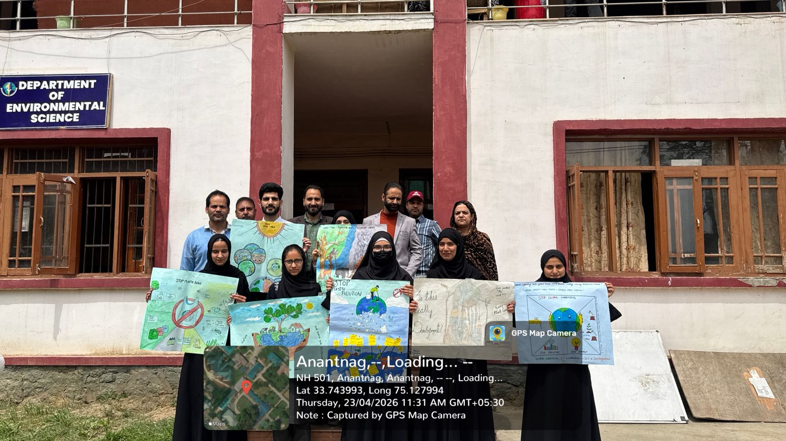
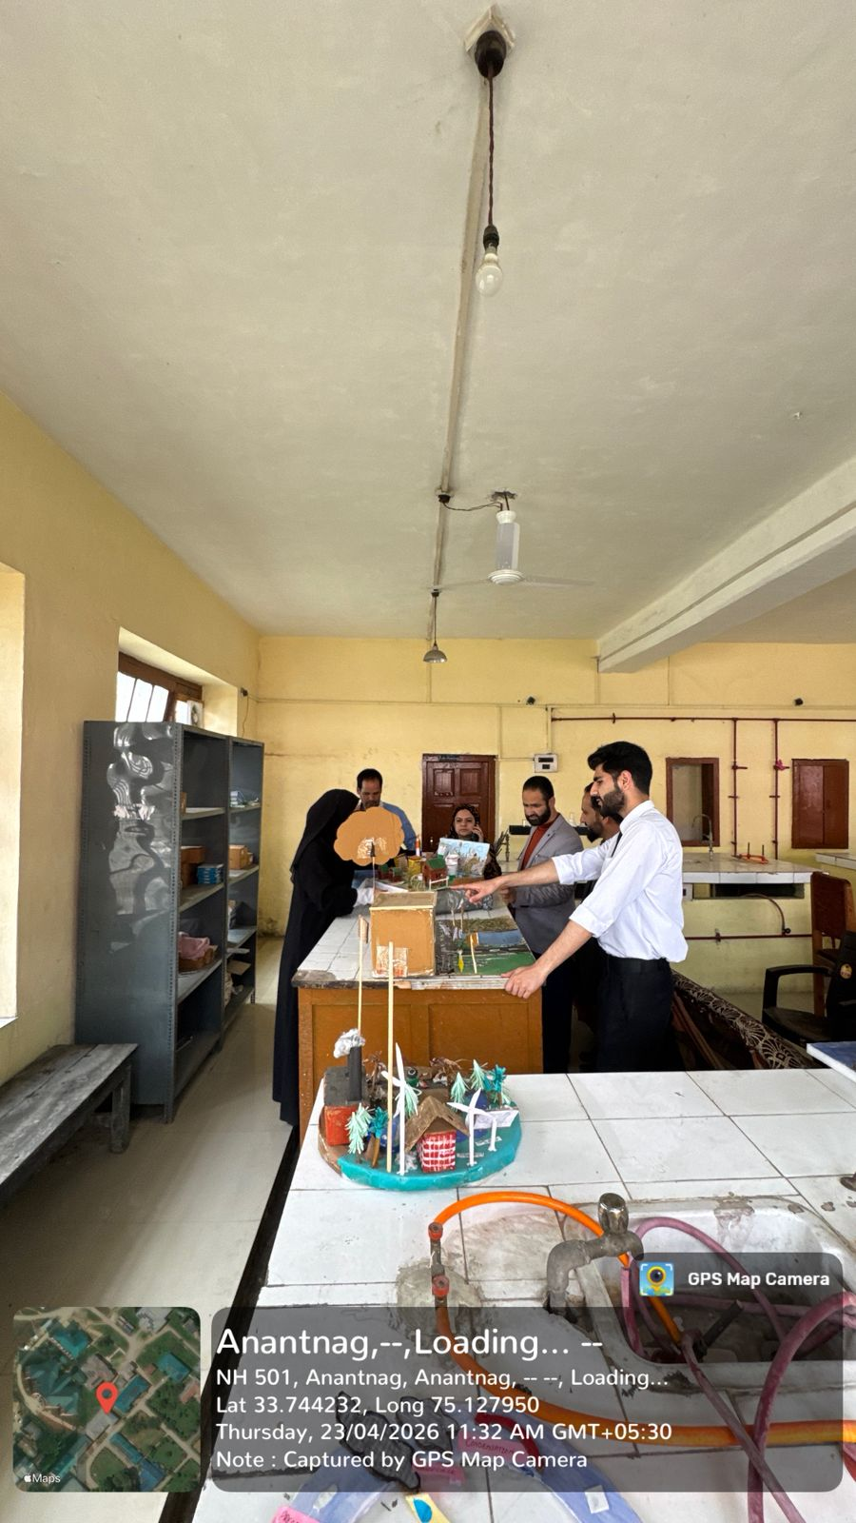
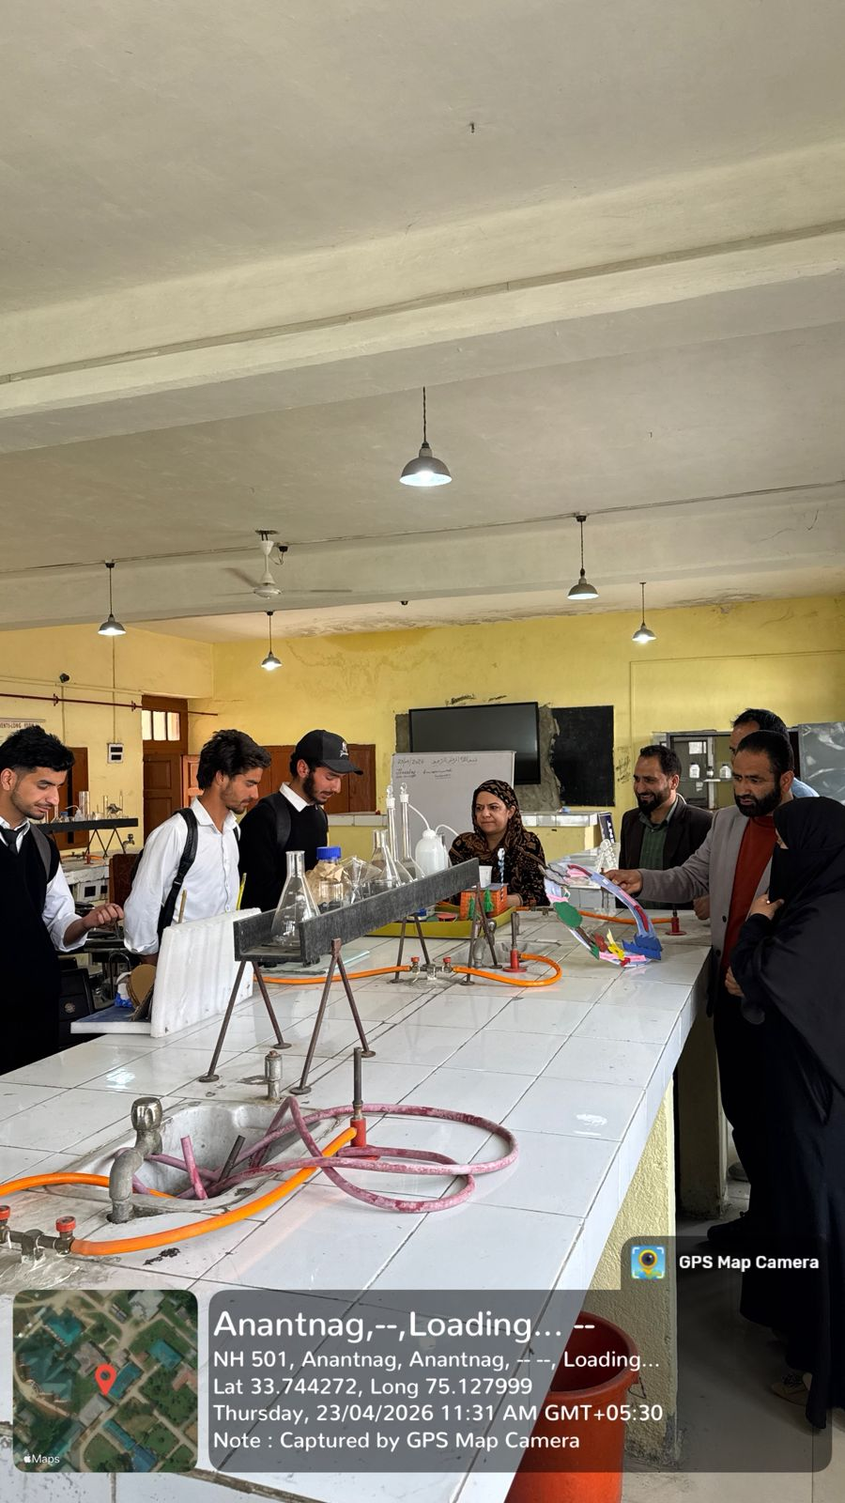
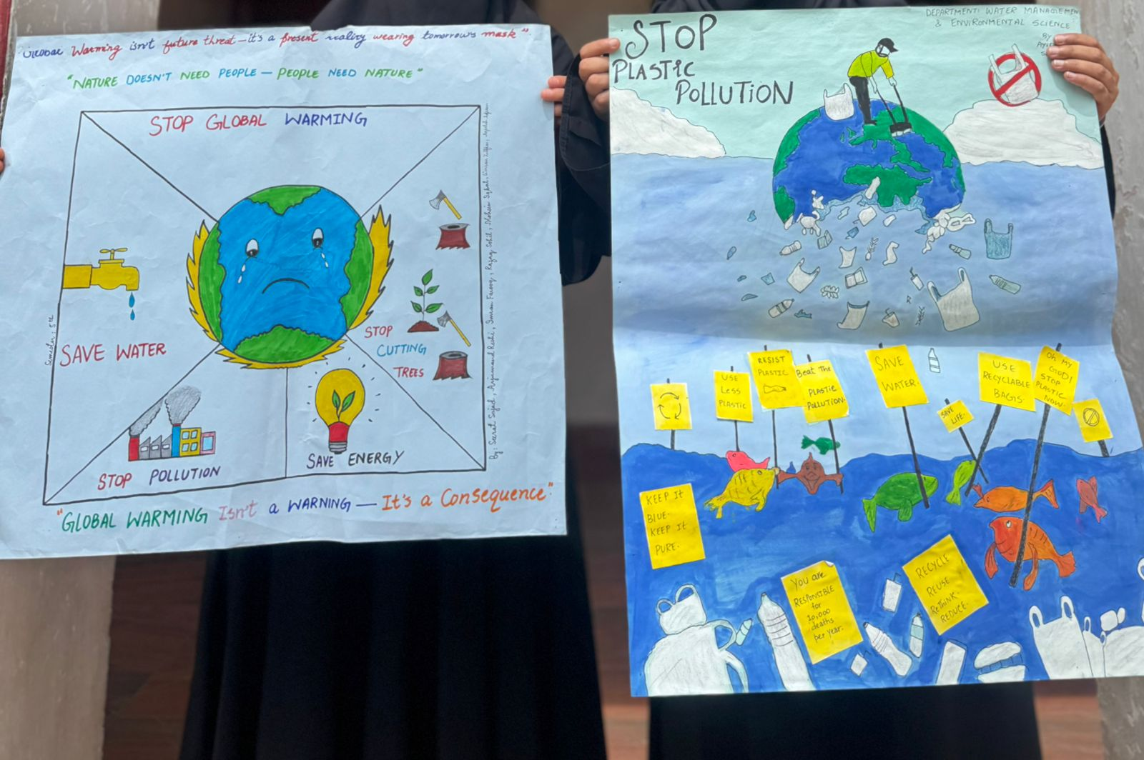
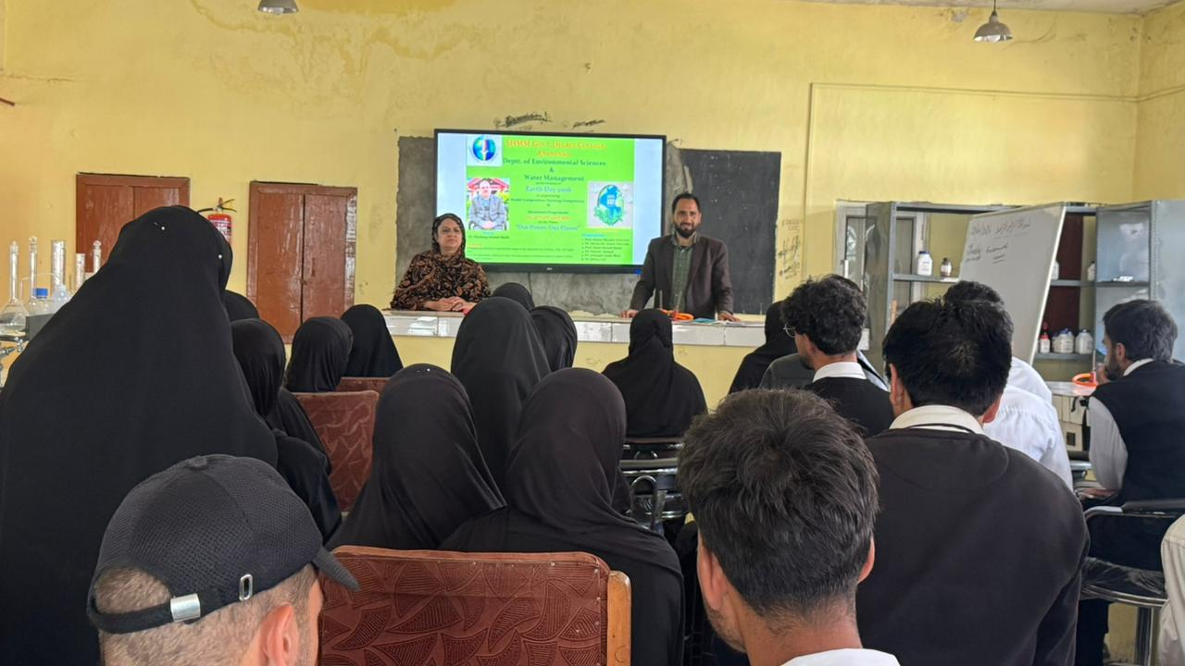

Prof. Saima Munshi Dr Sartaj Ah Ganie Dr Mushtaq Ahmad Malik
HOD HOD Principal
Envi. Sciences Water Management

