SHMM GOVERNMENT DEGREE COLLEGE ANANTNAG

Department of Environmental Sciences and
NSS UNITS, SHMM GDC ANANTNAG

REPORT OF INTER-COLLEGE PAINTING COMPETITION on 11th August, 2026 in connection with celebration of INDEPENDENCE DAY, 2026

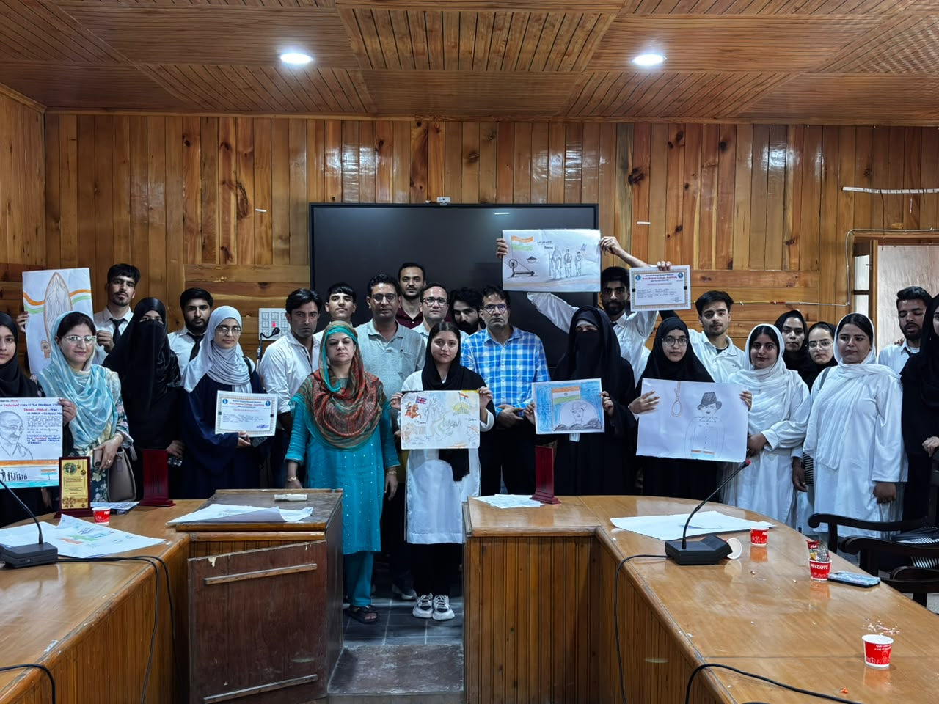
An Inter-College Painting Competition was organized at Shaheed Himayun Muzzamil Memorial (SHMM) Government Degree College Anantnag on 11th August, 2026 with the objective of providing students with a platform to showcase their creativity, imagination and artistic talent in connection with celebration of INDEPENDENCE DAY, 2026.A total of 8 colleges of Anantnag District participated in the event.The proceedings of the event were carried by Prof. Saima Munshi( NSS Programme Officer III)The competition provided an opportunity to the participants to express their thoughts and ideas through colours and artistic compositions. The students displayed considerable creativity, originality and enthusiasm while preparing their paintings. The activity also encouraged healthy competition and promoted artistic expression among the students.
The paintings submitted by the participants were evaluated by the designated jury namely Dr. Naveen Hakhoo (SHMM GDC Anantnag) , Dr. Ummer Rashid Zargar( GDC Dooru) and Prof. Nisar Kumar (GDC Kokernag )on the basis of creativity, originality, composition, relevance to the theme and overall artistic presentation. First position was secured by Bazila Altaf(GDC Womens Anantnag, second position was secured by Mehak Rayees (SHMM GDC,Anantnag) and third position was secured by Malik Ifham( GDC,Vailoo)
The programme concluded with the vote of thanks by Dr. Peerzada Yasir Yousuf( NSS Programme Officer I). The organizers expressed their gratitude to the worthy Principal and the college administration for their support. Light refreshment was provided to the participants.
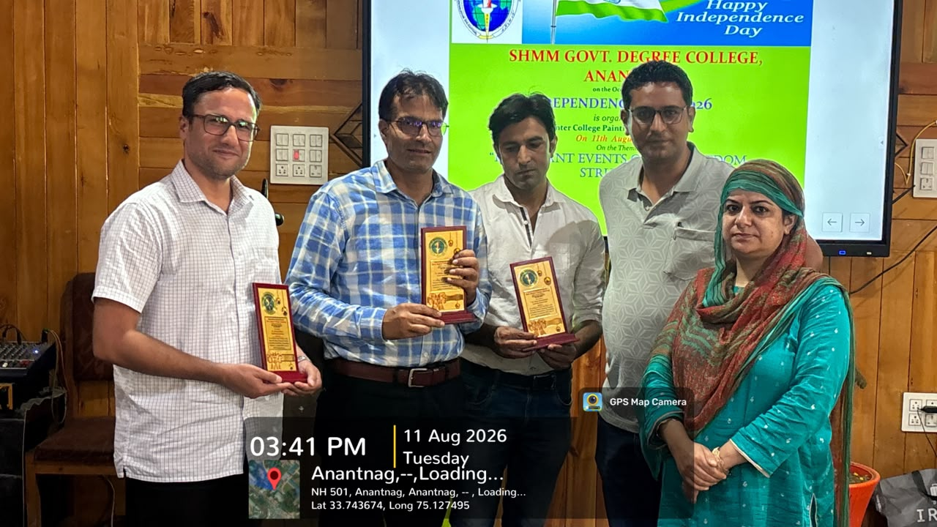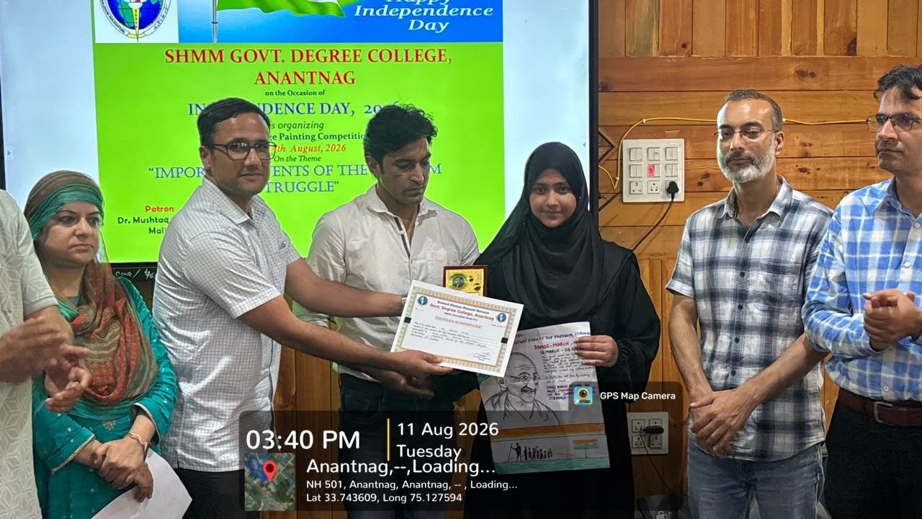
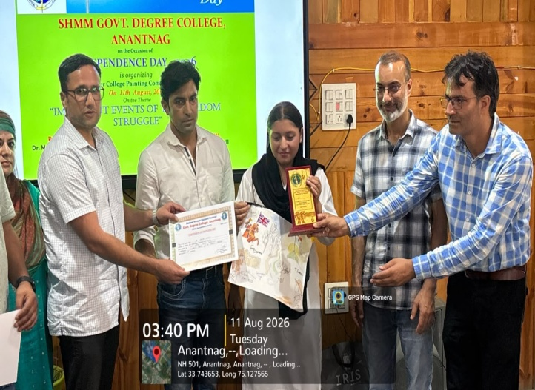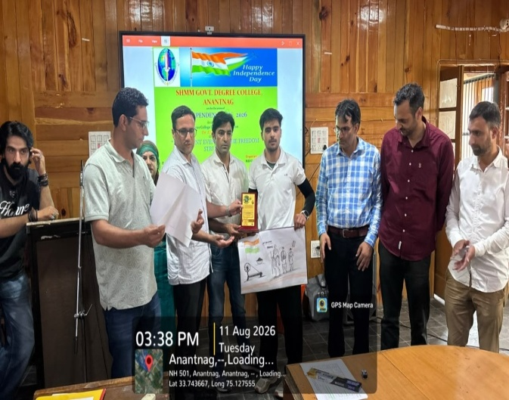
Report submitted by HoD (EVS) Principal
Prof. (Dr) Mushtaq Ahmad Malik

